Multivariable Normal distribution

* First one is more wide as covar = 0
* Second one is slimmer as covar is 0.5 and hence the points are nearby
* Third one is even more slimmer as covar is 0.8 and hence the points are even more nearby

Here the third axis shows p(x) 🡪 Probability density function

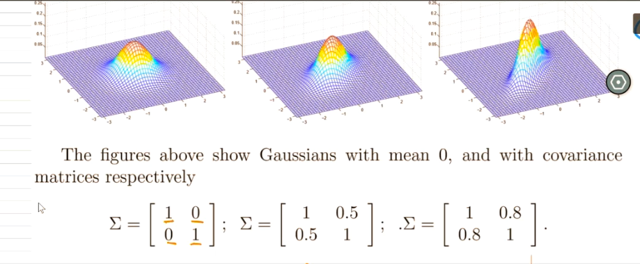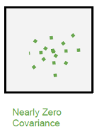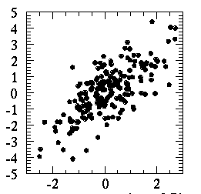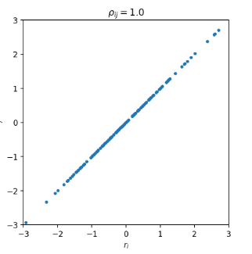

Co-Variance 0.5 Co-Variance 1.0